Experiment 11 – Configure Ansible Setup In Linux:

# Steps:

1. Create two Amazon Linux t2.micro instance - Ansible Server & Node

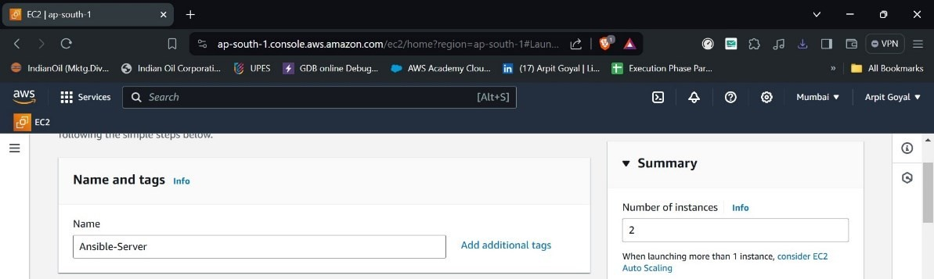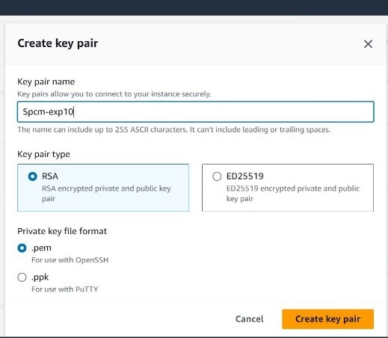

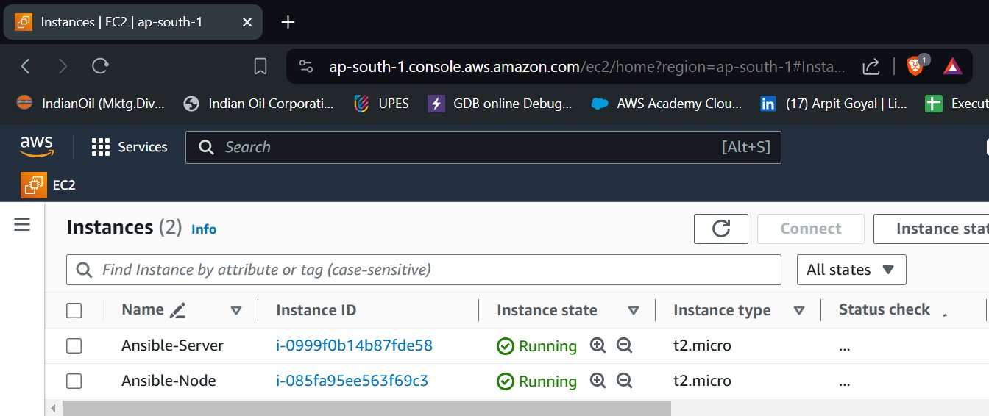

1. Install ansible on Ansible Server

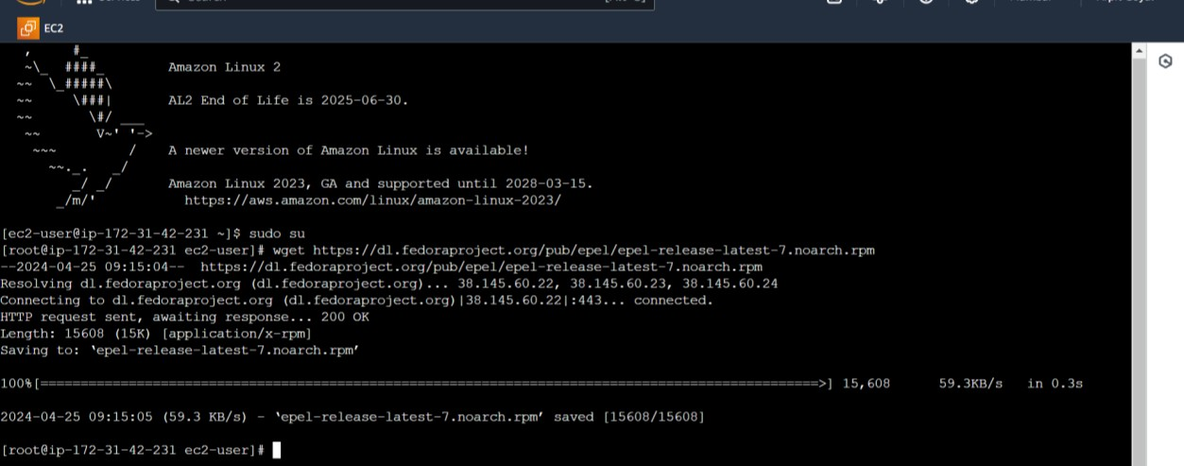

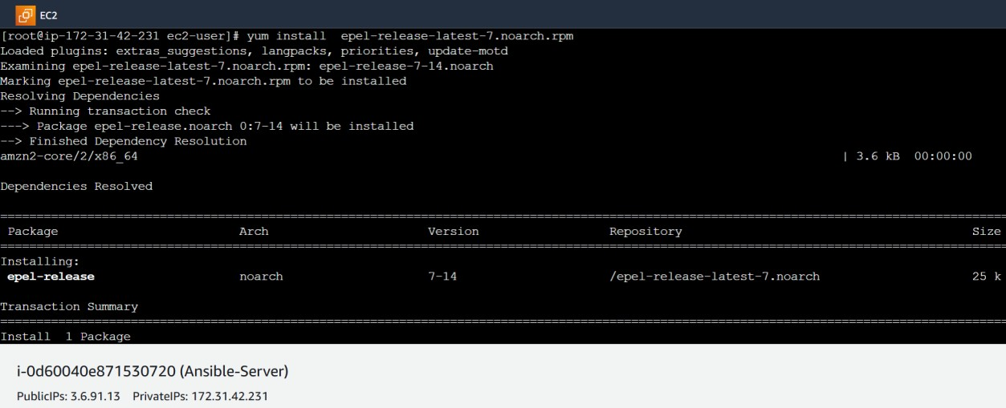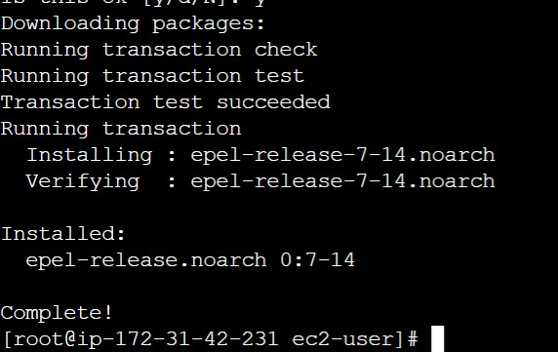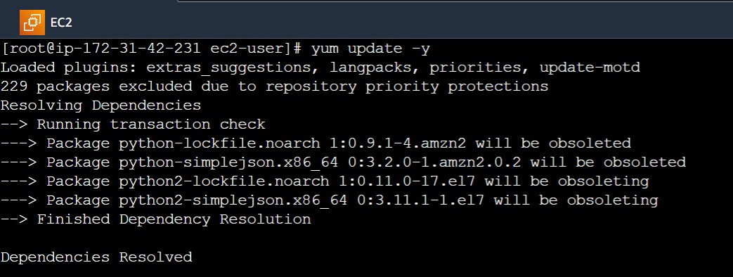

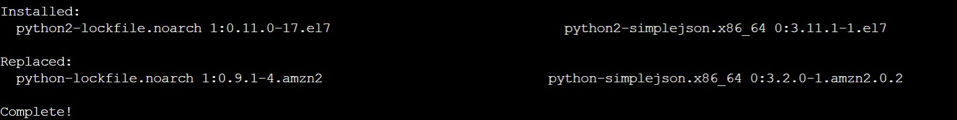

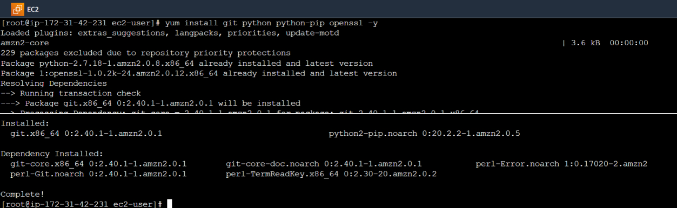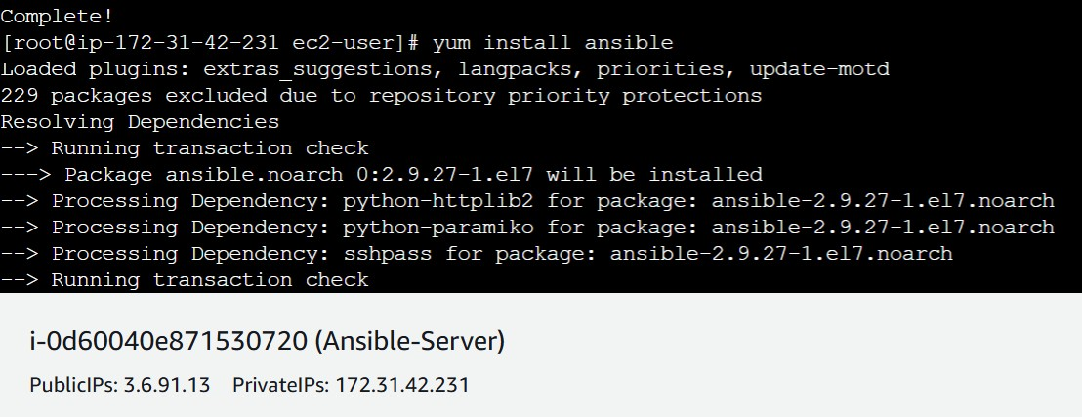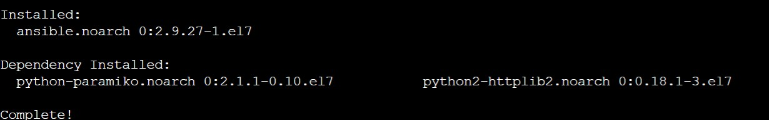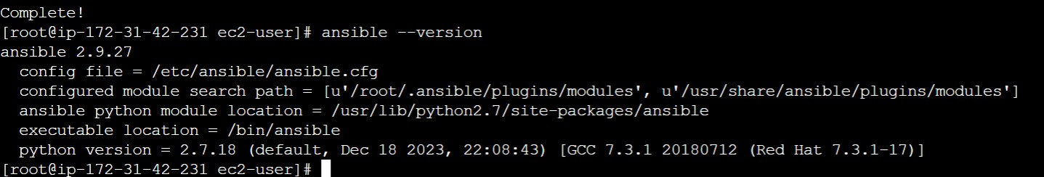

1. Connect Node to Ansible Server and Add Private IP of node to the Ansible server’s inventory file

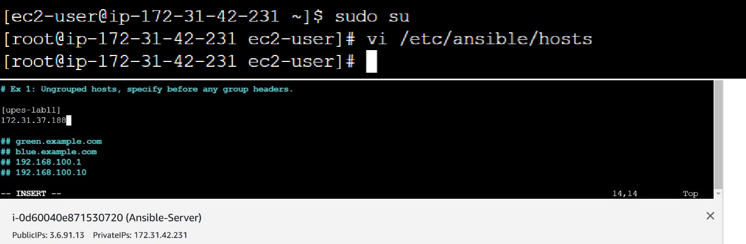

1. Create super user in both the machines

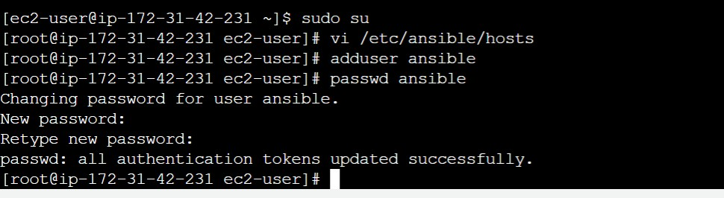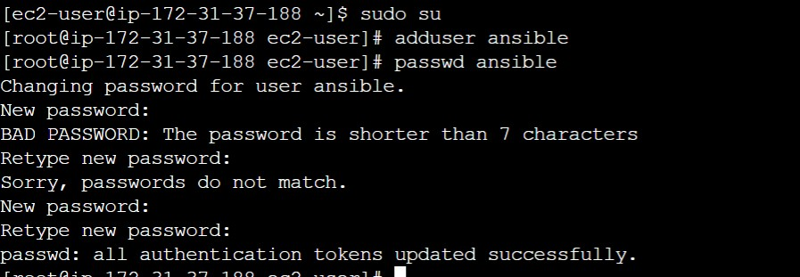

1. Give sudo user permissions to both users

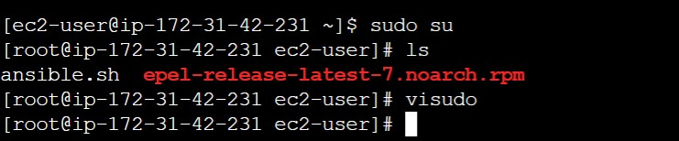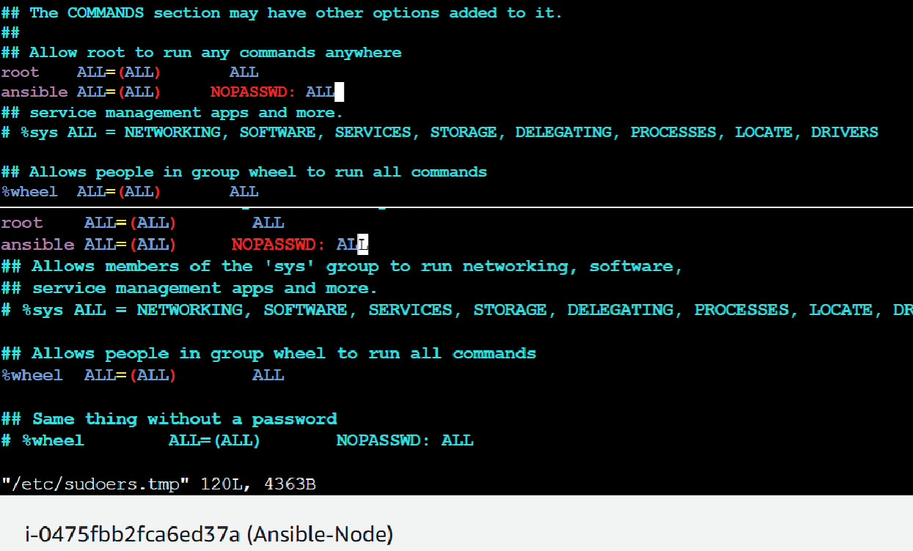

1. Edit the sshd_config file in the node server

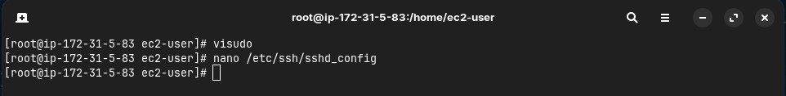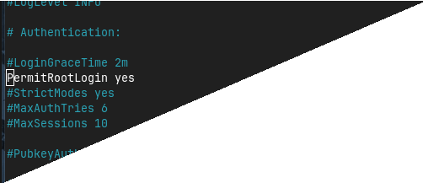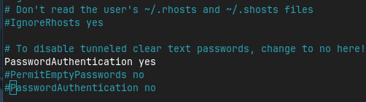

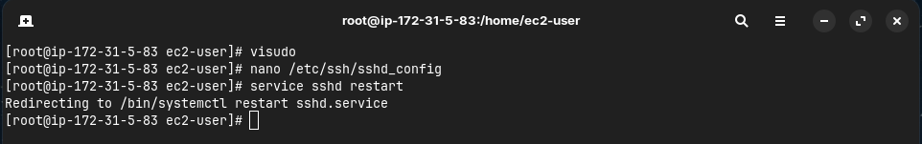

1. Generate key pair in Ansible server and copy the key to node server
2. Connect to node server from ansible server

